Module 4 Computational Lab Assignment README Notes
Arya C

This computational lab assignment concludes the first part of our course, starting from picking our disease, to then identifying gene targets, and now finally assessing if any of the gene targets are potentially druggable. The disease I had chosen is leukemia, specifically pediatric leukemia, however due to lack of proteomic data for it, it is supplemented with non-pediatric AML data. As mentioned in the last README, this therefore means that all my results are more of “potential ideas” rather than actual leads. But I do plan to revisit this code soon with a more concrete idea of what I want it to do. Again, the code was primarily generated by Northeastern’s Claude Ai, and I have described the functions it had used and why.
Firstly, the gene targets I have chosen are LY86 and EVI2A. LY86 ranked #2 and EVI2A ranked #4 on my targets_csv file. I chose these targets because firstly, LY86 is a key regulator of immune response and has been identified as a potential driver of leukemia, and EVI2A is a transcription factor that has been implicated in the development of leukemia. Both promising, and I wanted to go with a “sure-fire shot” and a “shot in the dark”.
Next, moving to the pLDDT. LY86 had all its low-pLDDT residues at the N-terminus (1–6, 9, 11–13, 15–23), which were broken up by a few residues above 50, so the 10-residue rule reports "none". This region overlaps the signal peptide (1–20), which is cut off the mature protein. EVI2A on the other had mostly low confidence. The low stretches at 79–89 and 97–109 are in the part outside the cell, and 212–227 is in the tail inside the cell. The Claude Ai wrote a list comprehension over ca.items() that builds one dict per gene and turned it into a data frame.
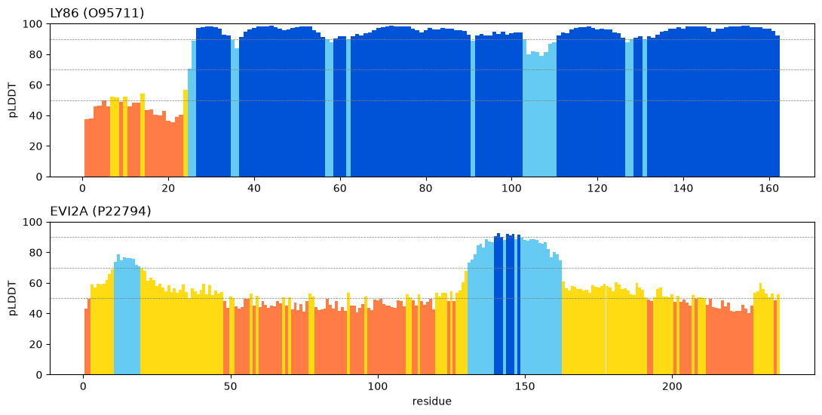
Next, step 4 read PAE to identify potential domains in LY86 and EVI2A. Results indicate that LY86 has one confident domain, 25–162 (138 residues), and EVI2A has one confident domain, 131–162 (32 residues) which is essentially the transmembrane helix. The inter-domain PAE is NaN for both, because neither has two domains. Based on the table below, trust all of LY86 from 25 to 162. For EVI2A, only a short helix passes, and a single helix inside the membrane isn't a credible pocket region. For overall confidence, LY86 is high confidence apart from the signal peptide. EVI2A is mostly low-confidence, with only a 32-residue helix that passes. For this step, Claude used find_domains(pae[g], ca[g].b), then the mean of the two PAE blocks between domain 1 and domain 2. Find_domains uses pLDDT ≥ 70 to decide which residues are confident.
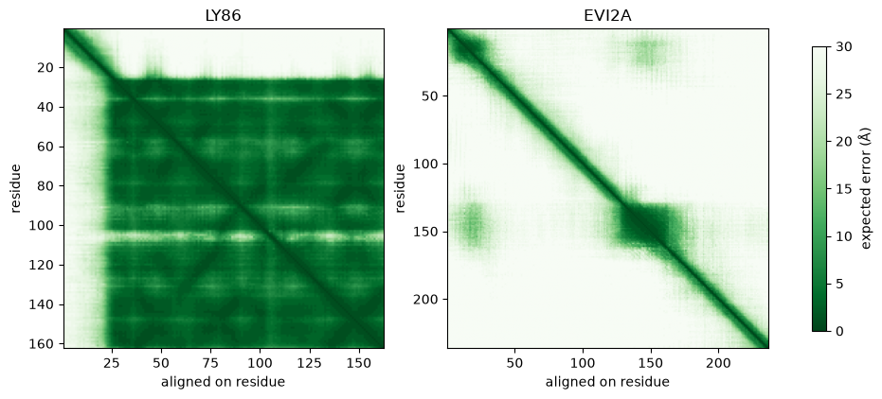

Next, in step 5 which compares against the experimentally generated structure, LY86 was compared against PDB 3B2D chain C, where 137 aligned pairs, all 137 identical and confident. RMSD 0.58 Å. This is excellent agreement and validates the model. The residues that differed the most were 36 (3.2 Å), 132 (1.9 Å), 35 (1.7 Å), 131 (1.7 Å), 106 (1.1 Å), 130 (1.1 Å), which are all probably surface-level loops. I could not find a PDB structure for EVI2A, so it's assessed on pLDDT and PAE alone. For this section, Claude used the use = function, which pairs with matching amino acids and AlphaFold pLDDT ≥ 70; kabsch() on those coordinates. Additionally, Step 5 superimposes only on identical residues that AlphaFold is confident about, as the assignment specifies. Mismatched or low-confidence residues would inflate the RMSD with noise unrelated to how accurate the fold is.
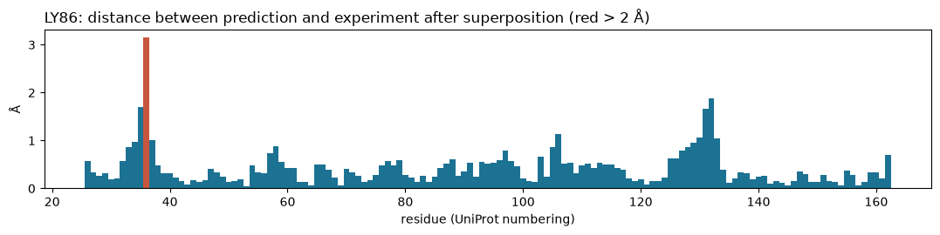

Moving to step 6, which had already been given to us, we identified that LY86 had 14 pockets, of which 13 were kept and 1 rejected. Pocket 14 had a druggability score of 1.000, volume about 1,884 Å³, pLDDT 95.0, PAE 2.8 Å, rank 1, and is therefore kept. It has 42 lining residues spread across the fold. This is most likely MD-1's hydrophobic lipid-binding cavity; check this against the literature. The next-best pockets score about 0.004 or less, so pocket 14 is the only meaningful one. For EVI2A, 21 pockets were identified, of which 2 were kept and 19 rejected. Pocket 21 has a score of 0.532, pLDDT 78.0, PAE 8.4 Å, and is therefore kept. Its lining residues are 14, 17, 18, 21, 147 and 151, which join the signal peptide (cleaved) to the transmembrane helix (inside the membrane). It isn't a real pocket, even though it passed the filters. It only just passes, if the diagonal of the PAE block were left out, its PAE would be just over 10 Å, which would make it "suspect". Harking back to my “shot in the dark”, this mostly closes the coffin on EVI2A as a druggable target. Claude used mean_pLDDT with plddt.loc[r]; PAE_within with np.ix_, and verdict with nested np.where
Nearly finished, for step 7 and the druggability calls, it is determined that LY86 could support a small molecule pocket, with the evidence showing a confident model, experimental validation at 0.58 Å, and a top-scoring, confident pocket. Notable caveats are that no ligand confirms the pocket, and the cavity is large and greasy, which makes selective binding hard. "Possible but uncertain" is a defensible alternative. For EVI2A unfortunately, there is no possibility based on the evidence of a druggable target. Evidence shows a low-confidence model, no structure, and a "kept" pocket that's an artefact. There is, however, an extracellular region of the protein, which could suggest an antibody approach.
Finally for step 8, which is an anchor check against p53, I superimposed the AlphaFold model of p53 on chain B of 1TUP using the 192 confident residues they share, ones that had pLDDT ≥ 70. The RMSD was 0.68 Å, well within the 1–2 Å range that counts as very close. The largest deviations were in surface loops and at the ends of the chain. In 1TUP, C176, H179, R248, R273, C238 and C242 are zinc ligands, each within 2.3 Å of a zinc ion. R248 and R273 touch DNA directly, at 3.4 Å and 2.5 Å, and R249 lies nearby at 7.2 Å. R175, G245, R282 and Y220 do neither, so their role is structural.

